Purpose
- See that experimental probability approaches theoretical probability when a sufficient number of experiments are conducted.
- Use iSENSE to visualize and explore this effect.

Materials
- Container with 12 blocks; yellow, red, blue
- Computer, tablet, or iPad with internet connection
- Interactive website – www.isenseproject.org
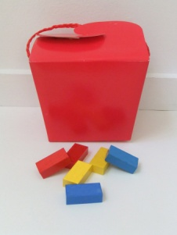
Method
- Divide into groups of 2 and gather materials.
- Without looking in the container, student 1, select one block from the container and note its color with a tally mark on Table 1. Replace the block back into the container.
- Without looking in the container, student 2, select one block from the container and note its color with a tally mark on Table 1. Replace the block back into the container.
- Students 1 and 2 take turns repeating steps 2 and 3 until each has tallied 5 outcomes, for a total of 10 outcomes.

 | Red | Blue | Green
Student 1
Student 2
Total
Table 1

- Enter your Totals from Table 1 into iSENSE (1 entry per couple)
- Click on Data, Manual Entry
- Enter the data set name i.e.: Group – FirstName & FirstName
- Click on Save

iSENSE Analysis
- Select your data set and click Visualize.
- Verify correct input of your data at Table.
- Use the Bar Chart to examine your data.
- Add data contributed by other participants and visualize using Bar Chart, or Histogram.
- Save any visualization that you find particularly interesting.

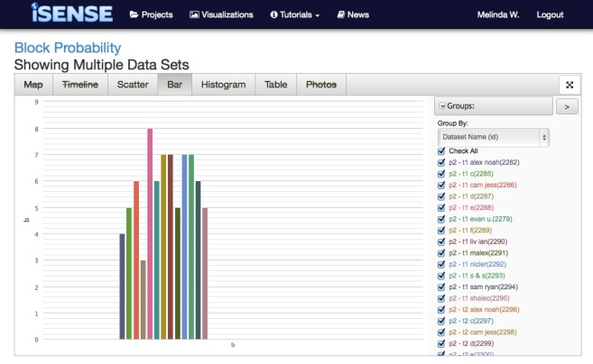

Discussion Questions
      - If we examine the experimental data from the entire class, does the experimental probability change? How?
      - Calculate the total, min, max, range, mean and mean deviation for blue and green blocks.
      - According to the results, how many blocks of each color are in the container?
      - According to the mean deviation, how reliable is your previous estimation?

